

***A Project Progress Report on***

**AN APPROACH TO HEALTHCARE SYSTEMS BASED ON INTERNET OF THINGS**

Submitted By

**Adithya Rao 4NM17EC007**

**Aditya Nayak 4NM17EC008**

**Adesh L 4NM18EC403**

**Deekshith K V 4NM18EC407**

Under the guidance of

**Mr. Sudarshana**

**Assistant Professor Gd.ll**

**DEPARTMENT OF ELECTRONICS & COMMUNICATION ENGINEERING**

**N.M.A.M. INSTITUTE OF TECHNOLOGY, NITTE - 574110**

**2019 – 2020**

**ABSTRACT**

The patient’s heart rate is monitored continuously through the heart beat sensor. This is done by Infra-Red Technology using voltage comparators and suitable multi stage amplifiers. This system can count the pulses of the Human and given as an input to the controller. Calculations with threshold values are programmed. A Temperature sensor LM35 is used to monitor the body temperature. A Blood Pressure Monitoring device with UART output is used to monitor the Blood Pressure of the Patient. The whole system is interfaced with a Wi-Fi Transceiver (ESP-8266). This can be configured as an access point as well as a Wi-Fi Device. It needs to be programmed with its network identity credentials like IP address, MAC address and Port number. Once configured, it can connect to any available network with internet/intranet, hence broadcasting the data from the sensor networks. The data or results can be monitored by any Mobile, Tablet, or PC which is already in the same network in case of a Local Area Network configurations. If the data is broadcasted with a static IP address over internet, then the data can be received and monitored from any part of the world by logging in to the respective IP address.

This advancement in Healthcare systems with approach to a concept of Internet Of Things proves to be a very useful application in the field of Medical treatments / Hospitalization.

# I. INTRODUCTION

In the present era of communication every thing is becoming mobile. People are now adapted to the idea of the world at its finger-tips. Control and communication has become important in all the parts of the world. As engineer’s main aim is to make life simple with the help of technology. The health care is a vast area requiring mobilization. The heart related diseases are growing day by day and more than 40% of the people above 50 years of age are in danger of heart diseases. One of the most important parameter in knowing the activity of the heart is the heart beat rate. A healthy man has a heart beat rate of 72 beats per minutes.

In the Internet of Things (IOT), devices gather and share information directly with each other and the cloud, making it possible to collect, record and analyze new data streams faster and more accurately. That suggests all sorts of interesting possibilities across a range of industries: cars that sense wear and tear and self-schedule maintenance or trains that dynamically calculate and report projected arrival times to waiting passengers.

But nowhere does the IOT offer greater promise than in the field of healthcare, where its principles are already being applied to improve access to care, increase the quality of care and most importantly reduce the cost of care. Embedded technologies are also being used in applications like Tele-Health systems that deliver care to people in remote locations and monitoring systems that provide a continuous stream of accurate data for better care decisions.

So we have attempted to develop a device which takes the heart beat rate, temperature and Blood Pressure reading as input and broadcasts the data to the assigned IP address through a wi-fi transceiver which can link to an existing internet source when configured as an access-point.

The results can be then accessed through a web-application to monitor the bio-medical readings through a remote computer with internet access, hence necessary treatments can be provided on time.

**II.LITERATURE SURVEY**

1. Vivek Pardeshi designed a Health Monitoring System using IoT and Raspberry Pi which monitors the Temperature, Blood Pressure, Heartbeat and ECG of a person using wearable sensors. Same data is transferred to the server through Raspberry Pi. Here, the energy consumption of data acquisition is reduced with MEMS Technology. Also, the energy efficiency in a processing unit is achieved by ultra-low power processors. And the data transmission is improved by integrating radio transceivers into SoCs. Any abnormalities in the health condition can be known directly and are informed to the particular person through GSM technology or via the Internet.
2. Amandeep Kaur implemented Health Monitoring based on IoT using Raspberry Pi. The system addresses social challenges faced during health monitoring of senior citizens and hence tries to improve their quality of life. The system is divided into two parts, namely Hardware and Software. The Hardware part contains Arduino UNO, KG011- Heartbeat Sensor, Raspberry Pi Board, DS18B20- Temperature Sensor whereas the software part includes IDE as a base for Arduino hardware. Node-RED is Open source programming tool for IoT. The system makes use of single board minicomputer Raspberry Pi and IBM Bluemix cloud for reliable service.
3. Arjun Aggarwal discussed an Efficient Methodology for Storing Sensitive Data using Nested Cloud. To provide security to cloud data, author proposed a model where different cloud storage is used to store data as well as the key. Again, key will get distributed to multiple parts using Shamir’s secret key sharing Algorithm. A threshold number of key shares will be required to reconstruct key. Similarly, data is also divided into several parts which will change paths dynamically and one separate directory is maintained to re-access data when a user wants.
4. Shashikant Ghumbre proposed an idea of Heart Disease Diagnosis using Support Vector Machine. Author has implemented a Decision Support System for diagnosis of heart disease using Support Vector Machine. The diagnosis of heart disease is carried out by taking different data samples from diverse patients. As the classification accuracy, sensitivity and specificity of SVM are high; it’s a good option for the diagnosis of heart disease.

**III.BLOCK DIAGRAM**

Unit-1: Transmitter With Sensor Networks

REGULATED POWER SUPPLY

LCD 16x2

PULSE SENSOR

LM35/TEMPERATURE SENSOR

BP KIT

ESP8266 WIFI

**STM32F103**

Unit-2: Receiver – Monitoring Unit

COMPUTER INTERFACE

PHP WEB APPLICATION

The patient’s heart rate is monitored continuously through the heart beat sensor. This is done by Infra-Red Technology using voltage comparators and suitable multi stage amplifiers. This system can count the pulses of the Human and given as an input to the controller. Calculations with threshold values are programmed. A Temperature sensor LM35 is used to monitor the body temperature. A Blood Pressure Monitoring device with UART output is used to monitor the Blood Pressure of the Patient. The whole system is interfaced with a Wi-Fi Transceiver (ESP-8266). This can be configured as an access point as well as a Wi-Fi Device. It needs to be programmed with its network identity credentials like IP address, MAC address and Port number. Once configured, it can connect to any available network with internet/intranet, hence broadcasting the data from the sensor networks. The data or results can be monitored by any Mobile, Tablet, or PC which is already in the same network in case of a Local Area Network configurations. If the data is broadcasted with a static IP address over internet, then the data can be received and monitored from any part of the world by logging in to the respective web address.

**IV. REQUIREMENT ANALYSIS**

|  |  |  |
| --- | --- | --- |
| **SL.NO.** | **Components** | **Specifications** |
| 1 | Regulated Power Supply | Power |
| 2 | STM32 F103 Microcontroller | Controller |
| 3 | LCD 16X2 | To display the parameters |
| 4 | LM35 Temperature Sensor | To measure the Temperature |
| 5 | BP Kit | To measure Blood Pressure and Heart Rate |
| 6 | ESP8266 | Wi-Fi module |
| 8 | PHP Web Application | Communication with Computer |

1. **Regulated Power Supply:**

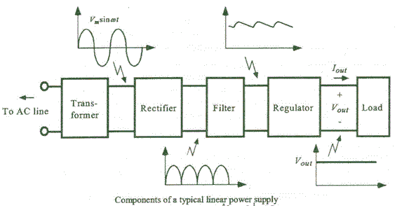

**THE BASIC BLOCKS OF A REGULATED DC POWER SUPPLY ARE AS FOLLOWS:**

**1. A STEP DOWN TRANSFORMER  
2. A RECTIFIER  
3. A DC FILTER  
4. A REGULATOR**

**OPERATION OF REGULATED POWER SUPPLY**

**STEP DOWN TRANSFORMER**

A step down transformer will step down the voltage from the ac mains to the required voltage level. The turn’s ratio of the transformer is so adjusted such as to obtain the required voltage value. The output of the transformer is given as an input to the rectifier circuit.

**RECTIFICATION**

Rectifier is an electronic circuit consisting of diodes which carries out the rectification process. Rectification is the process of converting an alternating voltage or current into corresponding direct (dc) quantity. The input to a rectifier is ac whereas its output is unidirectional pulsating dc. Usually a full wave rectifier or a bridge rectifier is used to rectify both the half cycles of the ac supply (full wave rectification).

### DC FILTERATION

The rectified voltage from the rectifier is a pulsating dc voltage having very high ripple content. But this is not we want, we want a pure ripple free dc waveform. Hence a filter is used. Different types of filters are used such as capacitor filter, LC filter, Choke input filter, π type filter. As the instantaneous voltage starts increasing the capacitor charges, it charges till the waveform reaches its peak value. When the instantaneous value starts reducing the capacitor starts discharging exponentially and slowly through the load (input of the regulator in this case). Hence, an almost constant dc value having very less ripple content is obtained.

### REGULATION

This is the last block in a regulated DC power supply. The output voltage or current will change or fluctuate when there is change in the input from ac mains or due to change in load current at the output of the regulated power supply or due to other factors like temperature changes. This problem can be eliminated by using a regulator. A regulator will maintain the output constant even when changes at the input or any other changes occur. Transistor series regulator, Fixed and variable IC regulators or a zener diode operated in the zener region can be used depending on their applications. IC’s like 78XX and 79XX are used to obtained fixed values of voltages at the output. With IC’s like LM 317 and 723 etc we can adjust the output voltage to a required constant value.

1. **STM32 F103 Microcontroller:**

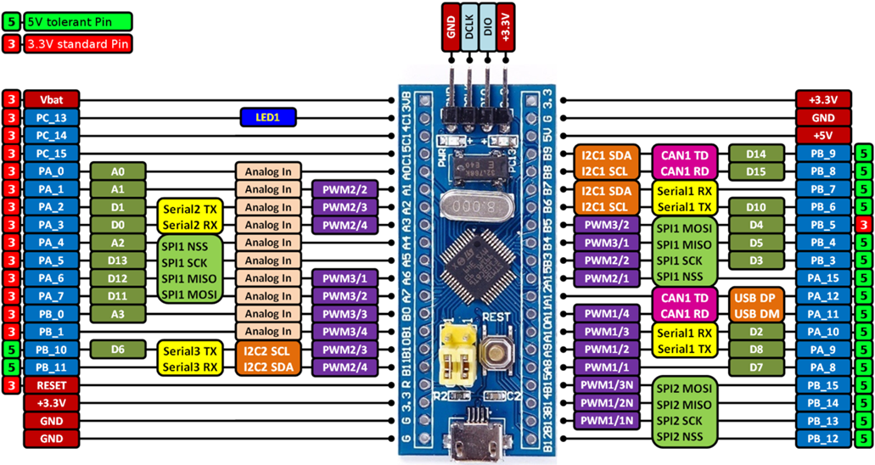

**The board is equipped with an** [**STM32F103C8T6**](http://www.st.com/content/st_com/en/products/microcontrollers/stm32-32-bit-arm-cortex-mcus/stm32f1-series/stm32f103/stm32f103c8.html) **microcontroller compatible with the** [**NUCLEO-F103RB**](https://developer.mbed.org/platforms/ST-Nucleo-F103RB/) **platform.**

|  |  |  |  |
| --- | --- | --- | --- |
| **STM32F103C8T6** | **SERIAL** | **SERIAL1** | **SERIAL2** |
| **RX** | **A10** | **A3** | **B11** |
| **TX** | **A9** | **A2** | **B10** |

**STM32F103C8 INTRODUCTION.**

The STM32F103xx medium-density performance line family incorporates the high-performance ARM Cortex-M3 32-bit RISC core operating at a 72 MHz frequency, high-speed embedded memories (Flash memory up to 128 Kbytes and SRAM up to 20 Kbytes), and an extensive range of enhanced I/Os and peripherals connected to two APB buses. All devices offer two 12-bit ADCs, three general purpose 16-bit timers plus one PWM timer, as well as standard and advanced communication interfaces: up to two I2Cs and SPIs, three USARTs, an USB and a CAN.

The devices operate from a 2.0 to 3.6 V power supply. They are available in both the ?40 to 85 ?C temperature range and the 40 to 105 ?C extended temperature range. A comprehensive set of power-saving mode allows the design of low-power applications.

The STM32F103xx medium-density performance line family includes devices in six different package types: from 36 pins to 100 pins. Depending on the device chosen, different sets of peripherals are included; the description below gives an overview of the complete range of peripherals proposed in this family.

These features make the STM32F103xx medium-density performance line microcontroller family suitable for a wide range of applications such as motor drives, application control, medical and handheld equipment, PC and gaming peripherals, GPS platforms, industrial applications, PLCs, inverters, printers, scanners, alarm systems, video intercoms, and HVACs.

**KEY FEATURES**

* **ARM 32-bit Cortex - M3 CPU Core**
  + 72 MHz maximum frequency,1.25 DMIPS/MHz (Dhrystone 2.1) performance at 0 wait state memory access
  + Single-cycle multiplication and hardware division
* **Memories**
  + 64 or 128 Kbytes of Flash memory
  + 20 Kbytes of SRAM
* **Clock, reset and supply management**
  + 2.0 to 3.6 V application supply and I/Os
  + POR, PDR, and programmable voltage detector (PVD)
  + 4-to-16 MHz crystal oscillator
  + Internal 8 MHz factory-trimmed RC
  + Internal 40 kHz RC
  + PLL for CPU clock
  + 32 kHz oscillator for RTC with calibration
* **Low-power**
  + Sleep, Stop and Standby modes
  + VBAT supply for RTC and backup registers
* **2 x 12-bit, 1 s A/D converters (up to 16 channels)**
  + Conversion range: 0 to 3.6 V
  + Dual-sample and hold capability
  + Temperature sensor
* **DMA**
  + 7-channel DMA controller
  + Peripherals supported: timers, ADC, SPIs, I2?Cs and USARTs
* **Up to 80 fast I/O ports**
  + 26/37/51/80 I/Os, all mappable on 16 external interrupt vectors and almost all 5 V-tolerant
* **Debug mode**
  + Serial wire debug (SWD) & JTAG interfaces
* **7 timers**
  + Three 16-bit timers, each with up to 4 IC/OC/PWM or pulse counter and quadrature (incremental) encoder input
  + 16-bit, motor control PWM timer with dead-time generation and emergency stop
  + 2 watchdog timers (Independent and Window)
  + SysTick timer 24-bit downcounter
* **Up to 9 communication interfacesCRC calculation unit, 96-bit unique ID**
  + Up to 2 x I2C interfaces (SMBus/PMBus)
  + Up to 3 USARTs (ISO 7816 interface, LIN, IrDA capability, modem control)
  + Up to 2 SPIs (18 Mbit/s)
  + CAN interface (2.0B Active)
  + USB 2.0 full-speed interface

1. **LCD 16X2:**

A **16x2 LCD** means it can display 16 characters per line and there are 2 such lines. In this LCD each character is displayed in 5x7 pixel matrix. This LCD has two registers, namely, Command and Data. The command register stores the command instructions given to the LCD. A command is an instruction given to LCD to do a predefined task like initializing it, clearing its screen, setting the cursor position, controlling display etc. The data register stores the data to be displayed on the LCD. The data is the ASCII value of the character to be displayed on the LCD.

|  |  |  |
| --- | --- | --- |
| **Pin No** | **Function** | **Name** |
| 1 | Ground (0V) | Ground |
| 2 | Supply voltage; 5V (4.7V – 5.3V) | Vcc |
| 3 | Contrast adjustment; through a variable resistor | VEE |
| 4 | Selects command register when low; and data register when high | Register Select |
| 5 | Low to write to the register; High to read from the register | Read/write |
| 6 | Sends data to data pins when a high to low pulse is given | Enable |
| 7 | 8-bit data pins | DB0 |
| 8 | DB1 |
| 9 | DB2 |
| 10 | DB3 |
| 11 | DB4 |
| 12 | DB5 |
| 13 | DB6 |
| 14 | DB7 |
| 15 | Backlight VCC (5V) | Led+ |
| 16 | Backlight Ground (0V) | Led- |
|  |  |  |

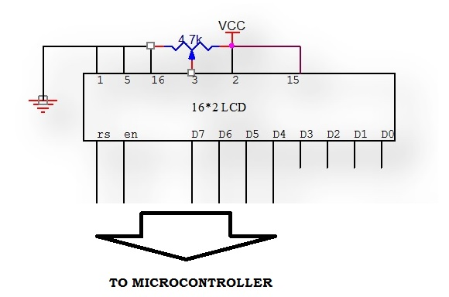

1. **LM35 Temperature Sensor:**

* Calibrated directly in ˚ Celsius (Centigrade)
* Linear + 10.0 mV/˚C scale factor
* 0.5˚C accuracy guaranteeable (at +25˚C)
* Rated for full −55˚ to +150˚C range
* Suitable for remote applications
* Low cost due to wafer-level trimming
* Operates from 4 to 30 volts
* Less than 60 µA current drain
* Low self-heating, 0.08˚C in still air
* Nonlinearity only ±1⁄4˚C typical
* Low impedance output, 0.1  for 1 mA load

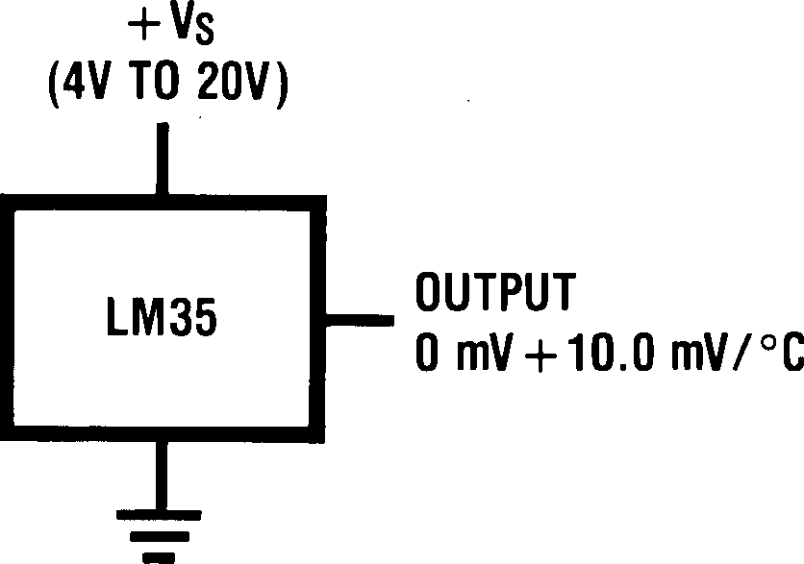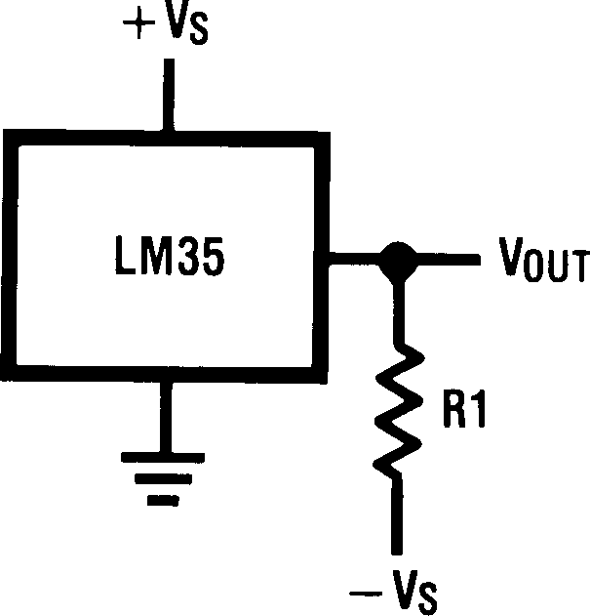

**Full Range Centigrade Temperature Sensor**

**Basic Centigrade Temperature Sensor (+2℃ to +150℃)**

1. **BP Kit:**

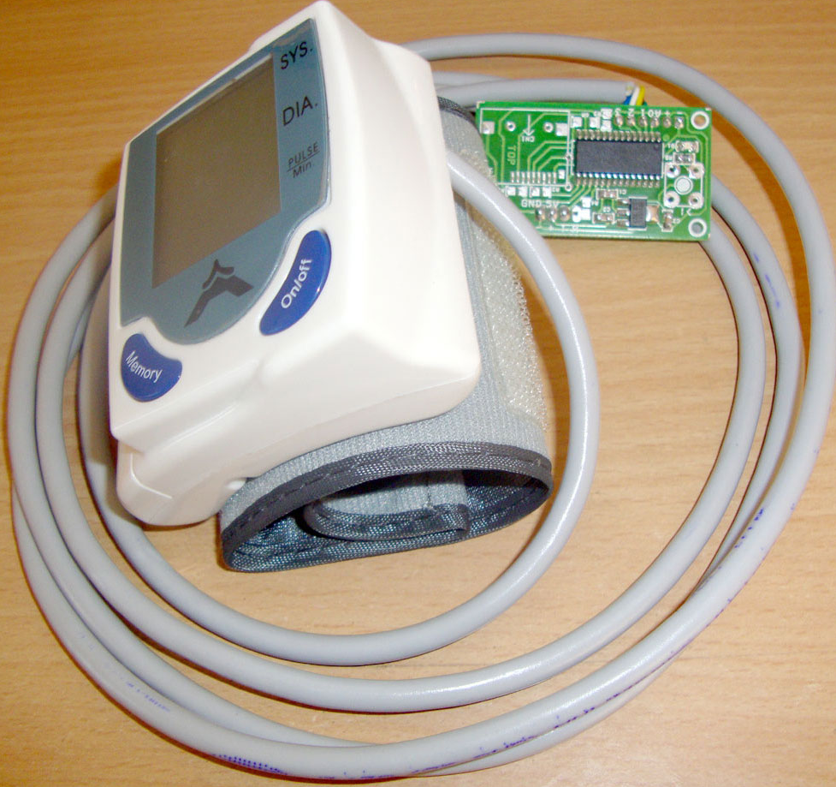

Blood Pressure & Pulse reading are shown on display with serial out for external projects of embedded circuit processing and display. Shows Systolic, Diastolic and Pulse Readings. Compact design fits over your wrist like a watch. Easy to use wrist style eliminates pumping.

**Features**

* Intelligent automatic compression and decompression
* Easy to operate, switching button to start measuring
* 60 store groups memory measurements
* Can read single or all measures
* 3 minutes automatic power saving device
* Intelligent device debugging, automatic power to detect
* Local tests for : wrist circumference as 135-195mm
* Large-scale digital liquid crystal display screen, Easy to Read Dsplay
* Fully Automatic, Clinical Accuracy, High-accuracy
* Power by External +5V DC
* Serial output data for external circuit processing or display.

**Specification**

* Working Voltage: +5V, 200mA regulated
* Output Format: Serial Data at 9600 baud rate (8 bits data, No parity, 1 stop bits). Outputs three parameters in ASCII.
* Sensing unit wire length is 2 meters

**Sensor Pinouts**

* TX-OUT = Transmit output. Output serial data of 3V logic level, Usually connected to RXD pin of microcontrollers/RS232/USB-UART.
* +5V = Regulated 5V supply input.
* GND = Board Common Ground

1. **ESP8266 Wi-Fi module:**

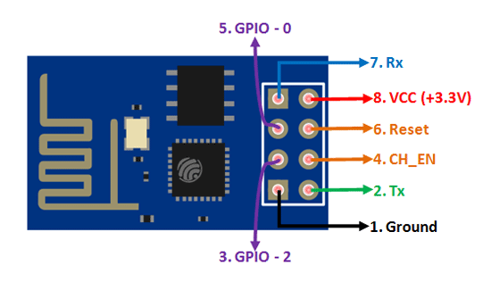

|  |  |  |
| --- | --- | --- |
| ***Function*** | ***AT Command*** | ***Response*** |
| Working | AT | OK |
| Restart | AT+RST | OK [System Ready, Ve[ndor:w](http://www.ai-thinker.com/)ww[.ai-thinker.com](http://www.ai-thinker.com/)] |
| Firmware version | AT+GMR | AT+GMR 0018000902 OK |
| List Access Points | AT+CWLAP | AT+CWLAP +CWLAP:(4,"RochefortSurLac",- 38,"70:62:b8:6f:6d:58",1)  +CWLAP:(4,"LiliPad2.4",-83,"f8:7b:8c:1e:7c:6d",1)  OK |
| Join Access Point | AT+CWJAP?  AT+CWJAP="SSID","Password" | Query AT+CWJAP? +CWJAP:"RochefortSurLac" OK |
| Quit Access Point | AT+CWQAP=? AT+CWQAP | Query OK |
| Get IP Address | AT+CIFSR | AT+CIFSR 192.168.0.105  OK |
| Set Parameters of Access Point | AT+ CWSAP?  AT+ CWSAP= <ssid>,<pwd>,<chl>, <ecn> | Query ssid, pwd  chl = channel, ecn = encryption |
| WiFi Mode | AT+CWMODE? AT+CWMODE=1  AT+CWMODE=2 AT+CWMODE=3 | Query STA  AP BOTH |
| Set up TCP or UDP connection | AT+CIPSTART=? (CIPMUX=0) AT+CIPSTART =  <type>,<addr>,<port> (CIPMUX=1) AT+CIPSTART=  <id><type>,<addr>, <port> | Query  id = 0-4, type = TCP/UDP, addr = IP address, port= port |
| TCP/UDP  Connections | AT+ CIPMUX? AT+ CIPMUX=0  AT+ CIPMUX=1 | Query Single  Multiple |
| Check join devices' IP | AT+CWLIF |  |
| TCP/IP Connection  Status | AT+CIPSTATUS | AT+CIPSTATUS? no this fun |
| Send TCP/IP data | (CIPMUX=0) AT+CIPSEND=<length>;  (CIPMUX=1) AT+CIPSEND= <id>,<length> |  |
| Close TCP / UDP  connection | AT+CIPCLOSE=<id> or AT+CIPCLOSE |  |
| Set as server | AT+ CIPSERVER= <mode>[,<port>] | mode 0 to close server mode; mode 1 to open; port = port |
| Set the server  timeout | AT+CIPSTO?  AT+CIPSTO=<time> | Query  <time>0~28800 in seconds |
| Baud Rate* | AT+CIOBAUD?  Supported: 9600, 19200, 38400, 74880,  115200, 230400, 460800, 921600 | Query AT+CIOBAUD? +CIOBAUD:9600 OK |
| Check IP address | AT+CIFSR | AT+CIFSR 192.168.0.106  OK |
| Firmware Upgrade (from Cloud) | AT+CIUPDATE | 1. +CIPUPDATE:1 found server  2. +CIPUPDATE:2 connect server  3. +CIPUPDATE:3 got edition  4. +CIPUPDATE:4 start update |
| Received data | +IPD | (CIPMUX=0): + IPD, <len>:  (CIPMUX=1): + IPD, <id>, <len>: <data> |
| Watchdog Enable* | AT+CSYSWDTENABLE | Watchdog, auto restart when program errors occur: enable |
| Watchdog Disable* | AT+CSYSWDTDISABLE | Watchdog, auto restart when program errors occur: disable |

**V. WORKSPLIT**

|  |  |
| --- | --- |
| **Month** | **Work Progress** |
| September | Collecting ideas for the project. Checking the availability of the components. |
| October | Literature survey |
| November | Building the block diagram and studying about the specification of the components. |
| February | Buying the Required Components |
| March | Integrating the Components |
| April | Programming the Microcontroller |
| May | Testing, Debugging and Preparing the Report |

**VI. WORK PROGRESS**

Successfully were able to integrate hardware components like BP kit, Temperature sensor, SP02 sensor with STM microcontroller and ESP2866 Wi-Fi module. Also we loaded the STM microcontroller with program to read values from those sensors and display it in LCD.

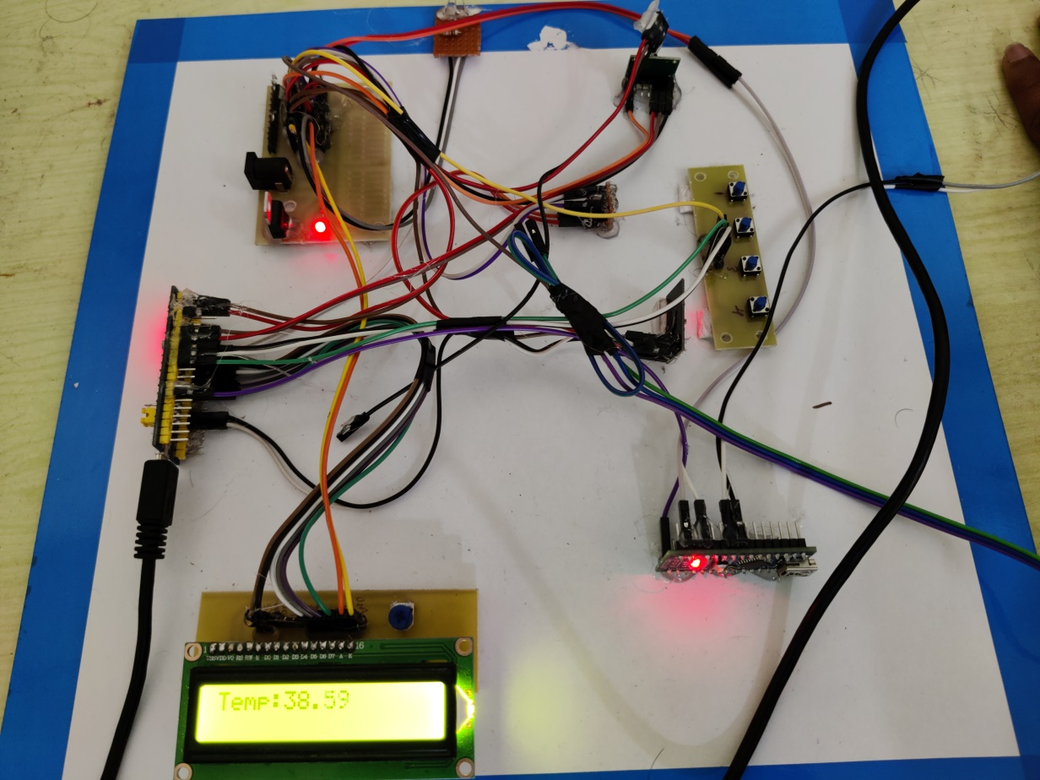

**VII. TIMELINE ESTIMATES**

**REFERENCES**

1. Vivek Pardeshi, Saurabh Sagar, Swapnil Murmuwar, Pankaj Hage, “Health Monitoring System using IoT and Raspberry Pi-A Review,” International Conference on Innovative Mechanism for Industry Application (ICIMIA 2017).
2. Amandeep kaur, Ashish Jasuja, “Health Monitoring Based on IoT Using Raspberry Pi”, International Conference on Computing, Communication and Automation (ICCCA 2017).
3. Arjun Aggarwal, Sushil Kumar Saroj, “An Efficient Methodology for Storing Sensitive Data using Nested Cloud”, Article in International Journal of Computer Applications, May 2016.
4. Shashikant U. Ghumbre, Ashok A. Ghatol, “Heart Disease Diagnosis Using Machine Learning Algorithm”, Proceedings of the International Conference on Information Systems Design and Intelligent Applications, January 2012.
5. [www.iteastdio.com](http://www.iteastdio.com)
6. [www.tutorialspoint.com](http://www.tutorialspoint.com)
7. [www.guru99.com](http://www.guru99.com)
8. <https://components101.com/adc0808-pinout-features-datasheet>
9. Prashant Patil, Rohan Waichal, Utkatsha Kumbhar, Vaidehi Gadkari, “Patient Health Monitoring System using IOT”, International Research Journal of Engineering and Technology (IRJET)
10. C Midhundas, George Antony, Seenia Francis, “Patient Monitoring System Using Raspberry PI”, International Journal of Science and Research (IJSR).